

**Name: Usama Habib**

**Regno: BCSP253027**

**Course: Information Security and Forensic Lab**

**Assignment: 1**

**Instructor: Sir, Moeez Javed**

cd



pwd

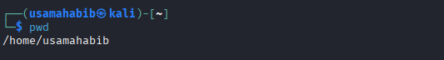

cat > auth.log << ‘EOF’

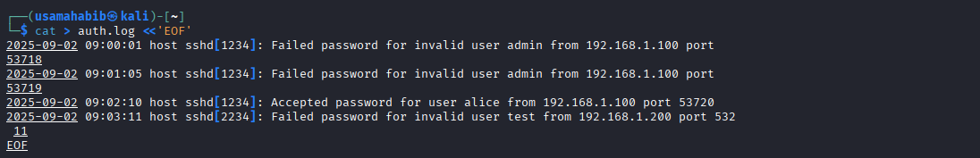

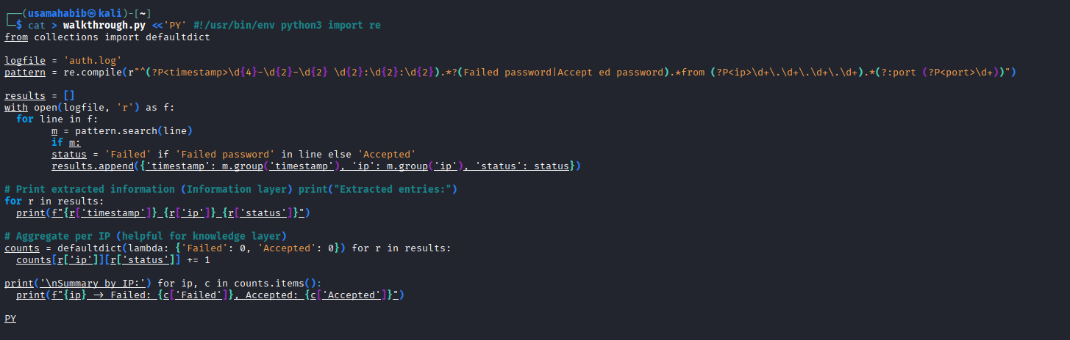

chmod +x walkthrough.py

python3 walkthrough.py

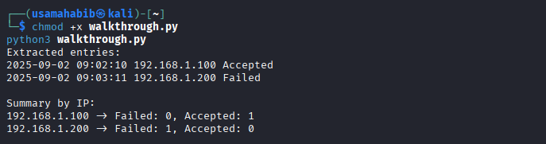

who



w

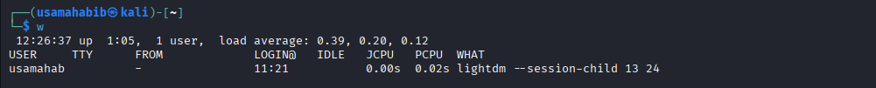

Last -a | head -n 10

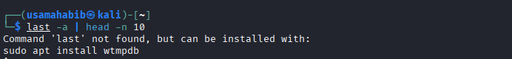

sudo chown root:root auth.log

sudo chmod 600 auth.log

ls -l auth.log

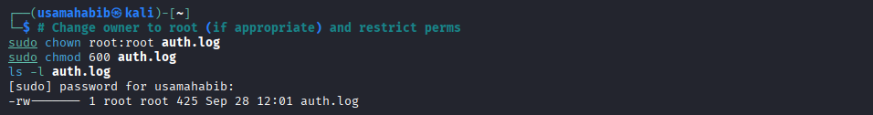

sha256sum auth.log > auth.log.sha256

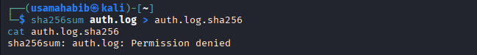

sudo iptables -A INPUT -s 192.168.1.100 -j DROP



sudo apt -y install iptables-persistent

sudo netfilter-persistent save

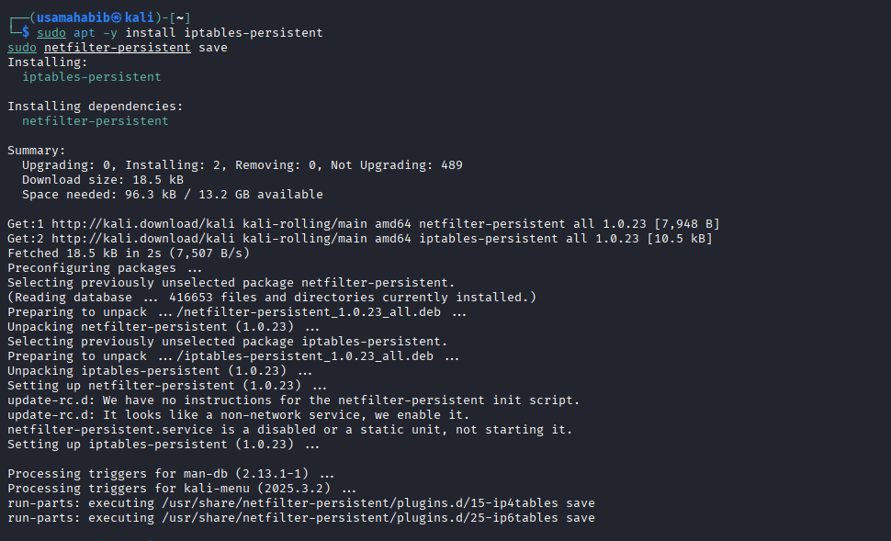

sudo iptables -L -n -v --line-numbers

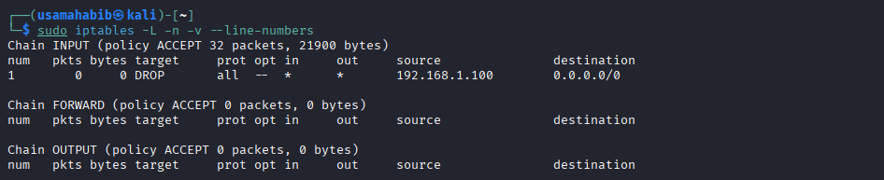

sudo iptables -D INPUT 3

